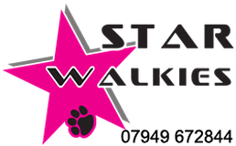
Star Walkies
White Briar Cottage
Duns Road
Grantshouse
Duns
TD11 3RW

starwalkies1970@gmail.com
0794 967 2844

Photo Release and Social Media Consent Form

I hereby grant Star Walkies in Grantshouse, Duns, and its representatives and employees, permission to use and/or publish photographs or videos of myself or my pet in print and/or electronically. I understand and agree that these materials will become the property of Star Walkies and will not be returned. I hereby authorize Star Walkies to edit, alter, copy, exhibit, publish, or distribute the photograph or video for purposes of publicizing their programs or for any other lawful purpose. In addition, I waive my rights to any compensation arising or related to the use of the photographs or videos. I release and discharge Star Walkies from any and all claims arising out of use of the photos or videos for any lawful purpose such as for publicity, illustration, advertising, and Web content.

Star Walkies has my permission to use: (Please check one below)

o Only my pet’s name(s)

o My pet’s name(s) and my last name

o My pet’s name(s) and my first and last name

In signing this consent, I give the authorization to use my name and my pet’s name as printed below.

Pet’s name(s): ________________________________________________________________________

Owner’s Printed Name: ________________________________________________________________

Owner’s Signature: ________________________________________________________________

Date: ____________________________________________________________________________

